Marketing Guide

## Background:

The food deliverer is the biggest cost driver, Robotic delivery will give the organization complete control over the core service while also decreasing reliance. The product's purpose is to fully automate the delivery service so that orders are delivered without delay, damage, missing orders

## Market background:

**Outline your target audience**

We offer this service to any user who has an incompleteness, lack of order,

or defect with an order problem by enabling them to choose one of these options.

**Target market**

In 2020, the total online food delivery market in the United States is expected to reach [$20.958 billion](https://www.statista.com/outlook/374/109/online-food-delivery/united-states) with over [111 million users](https://www.statista.com/outlook/374/109/online-food-delivery/united-states). Of this amount, the platform-to-consumer delivery segment will account for [$6.542 billion](https://www.statista.com/outlook/376/109/platform-to-consumer-delivery/united-states) and the restaurant-to-consumer delivery segment will account for [$14.415 billion](https://www.statista.com/outlook/374/109/online-food-delivery/united-states)

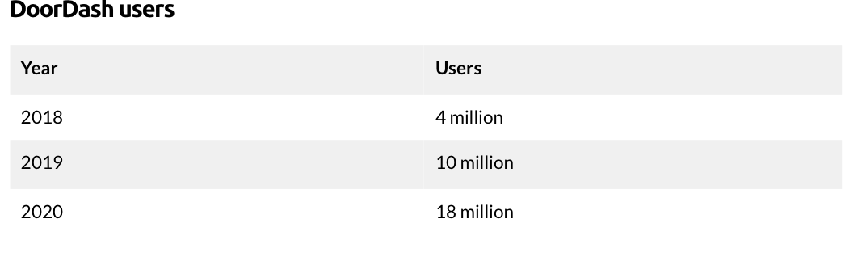

## Product Background and Positioning:

**product value proposition**

The service availability will be determined by the robots in operation at the time.

If robots are available, users can select robot delivery when placing their meal orders. That way, we can keep users interested in robot delivery while also managing technological obstacles with carefully and delivering orders completely.

**Main features**

One of the most significant aspects is availability 24 hours a day for delivering orders while maintaining the food's temperature.

How the robot handles missed orders, and the user has more options for how to handle a refund request from a user.

**Visual element**

[Mocks](https://www.figma.com/file/TJ1tBvkDBZQ2MfQ7ktOL7R/Doordash-Robodash?node-id=430%3A0)